High resolution License Plate Recognition Camera for Highway
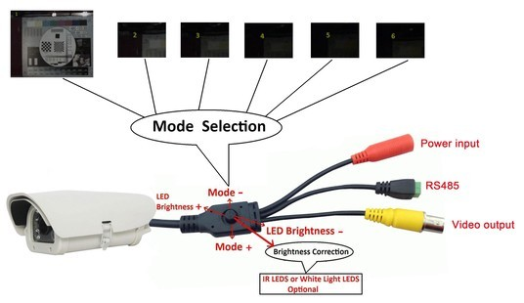
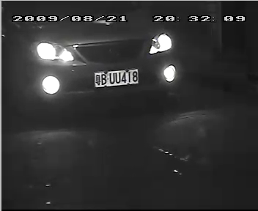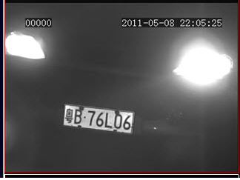
Description：
There are two model series about the LRP camera: white LEDs with short distance and slow speed for parking lot application, and IR LEDs with long distance and fast speed for traffic. Features：
1.The LPR cameras adopts high resolution CCD, the new ISP and high speed MCU design, which are very easy to use due to the wired button or RS485 different models and LED brightness adjusting. The optional model using with ground sensor can capture the license plate when the car is in and monitor the normal environment when the car pass away.
2.The built in fan and heater, double layer waterproof housing is weather-sealed and field proven for successful application in extreme environments.
3. Six kinds of mode selection with easy-operation
Specification:
Product name | High Resolution LPR Camera series
Video system | PAL/NTSC
Sensor | 1/3” SONY 960H Ex-view HAD II CCD
Pixel | PAL:976(H)x 582(V)/NTSC:976(H)x 494(V)
Resolution | Color:650TVL B/W: 700TVL
Video output | 1.0Vp-p/75Ω Video composite video signal
Capture mode | Modes1-6 selectable, display in the monitor
Addition function (Ground sensor model) | LPR function when the car is in, normally monitor when the car pass away, ground sensor model
LED | 4pcs IR Led
Lens | 5-50mm DC lens
Day/night | IR LED , B/W image and ICR auto switching for IR model
Power Supply | DC12V (±10%), 1A at DC12V(Max)
Work environment | -30degree~70degree,20%~90% RH
Temperature control | Heater works at –5degree(optional), fan works at 45degree
Dimension | 290x147x101(mm)

