360 Degree CCTV Panorama Dome Camera

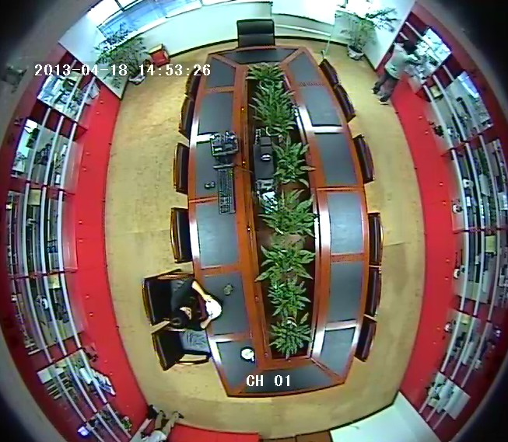
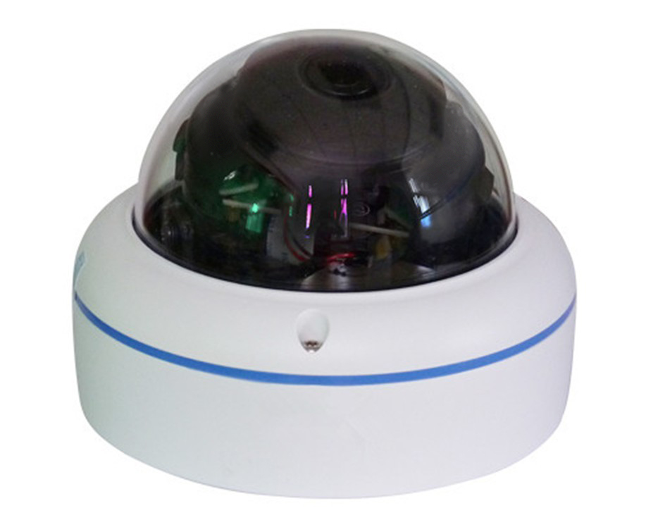

Features:
Sony 700TVL wide lens 360 degree CCTV camera security
1) 1/3’’ Sony HAD II CCD, and new ISP solution design.
2) High resolution Sony Effio-E 700TVL
3) Digital noise reduction can reduce the noise in low light.
4) Highlight suppression function will block out high-bright areas, and enables better.
5) visibility of other areas, an example of this function usage is to recognize the license
plates on a vehicle at night, where the headlights are too bright.
6) Shutter speed adjustable, good for monitoring moving objects, Lens shading correction.
7) Privacy mask, motion detection, high performance price ratio.
8) Removable IR cut filter can get the good image at day and improve the illumination at night.(optional model.)
9) Local OSD menu and RS485 remote control function are very convenient for construction and installation. (optional model) Multi-angle bracket convenient for installation and adjustment (water-proof model).
10) 3-axis housing which is easy to be installed and adjust monitor angle (vandal-proof model).

Technical specification:

Product Name | High resolution vandal-proof camera
Model | MF-FE360D
Imaging sensor | 1/3 “ SONY HAD II CCD
Pixel | PAL:795(H) x 596(V) /NTSC: 811(H) x 508(V)
Scanning | 2:1 Interlace
Sync. Mode | Internal
Horizontal/Vertical Frequency | PAL:15.625 kHz, 50.00 HZ NTSC :15.734kHZ,59.94HZ
Resolution | 700TVL
Video Output | 1.0Vp-p/75Ω Video composite video signal
S/N Ratio | >48dB Max
Illumination | 0.05Lux /F1.2
HLC | Yes
OSD | Yes
E-Shutter | PAL:1/50~1/100 000 s /NTSC:1/60~1/100 000s
D/N Mode | Auto day and night switching
Lens | 2.1mm Fisheye lens
Power Supply | DC12V±10% 2W
Operation Temperature and Humidity | -10°C~50°C, 20%~90% RH
Storage Temperature | -40°C~60°C
Dimension | Φ105*84mm
Weight | 380g

