360 Degree Panoramic HD IP Camera
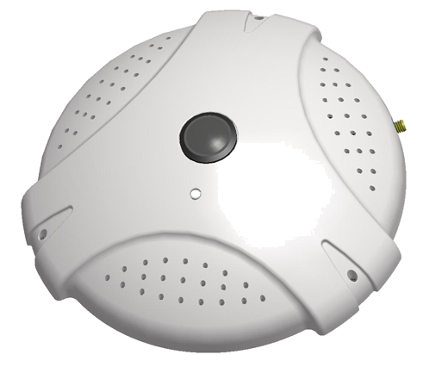
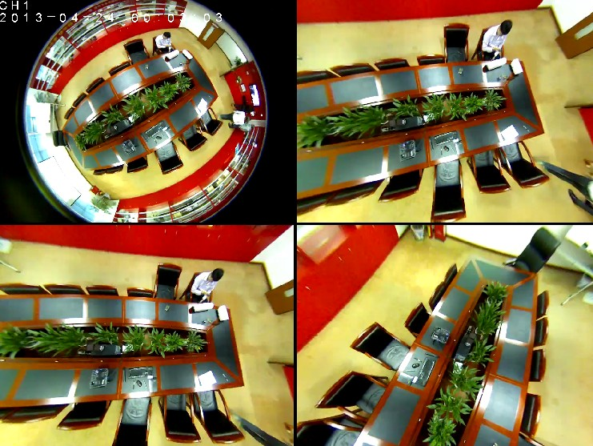



Features:
2 Mega pixels 360 degree Panoramic HD IP camera
•It adopts fish-eye panoramic imaging system, which haven’t blind area in the center.
•HD 2.0 megapixels output, huge vision cover and high resolution;
•It is fit for the meeting room, office room, hall, market, warehouse, plant room and some indoor area to monitor;
•Free Panosee panoramic surveillance system software, with un-warping software, six kinds of viewing modes in real time;
•Supply Windows SDK, which can access to third-party network management platform.
•Support POE power supply, digital PTZ, two way audio, SD card(max 32G)
•Do not support Onvif.

Technical specification:

Sensor | 2 Megapixels
Resolution | H.264 1080P/800*600/640*480
IR Cut | Built-in auto
Frame rate | 15ftp
OSD language | ENGLISH/Chinese
Intelligent record | original，panorama，2/3/4 separate
WDR | Digital WDR
Connector | RJ-45 ,10baseT/100baseTX DC jack， alarm，audio input /output RS485
Video Format | H.264, MPEG4, JPEG
Video plaback | Fast playing，real time playing
Ethernet | 10/100m Automatic synchronization
Lens | 360 degree Panoramic
Operating system | Windows 2000/XP/Vista/7
Power supply | DC12V 7W
Consumption | 7W(Max)
Work temperature | 0°C~50°C
Size | 180*45mm
Weight | 400g

